Project Design Phase-II
Data Flow Diagram & User Stories

Date | 15-7-2026
Team ID
Project Name | Book Store
Maximum Marks

Data Flow Diagrams:
The Book Store system allows customers to search, purchase, and manage books online while enabling sellers and administrators to manage inventory and orders. The data flows through different processes, databases, and users as follows:
Example:
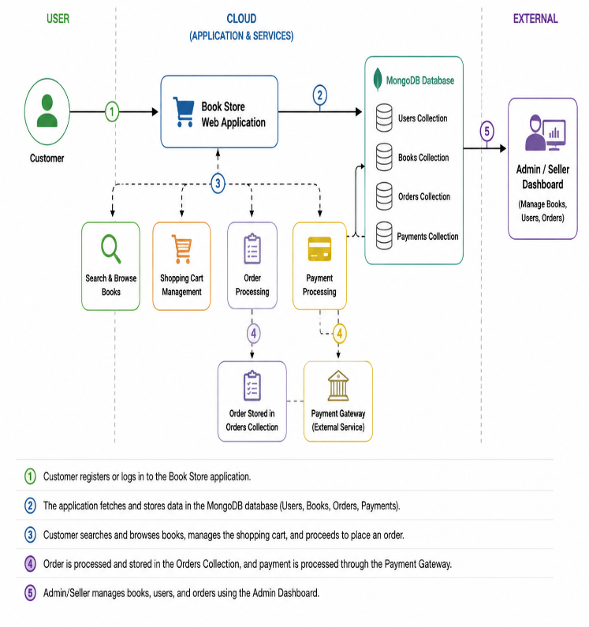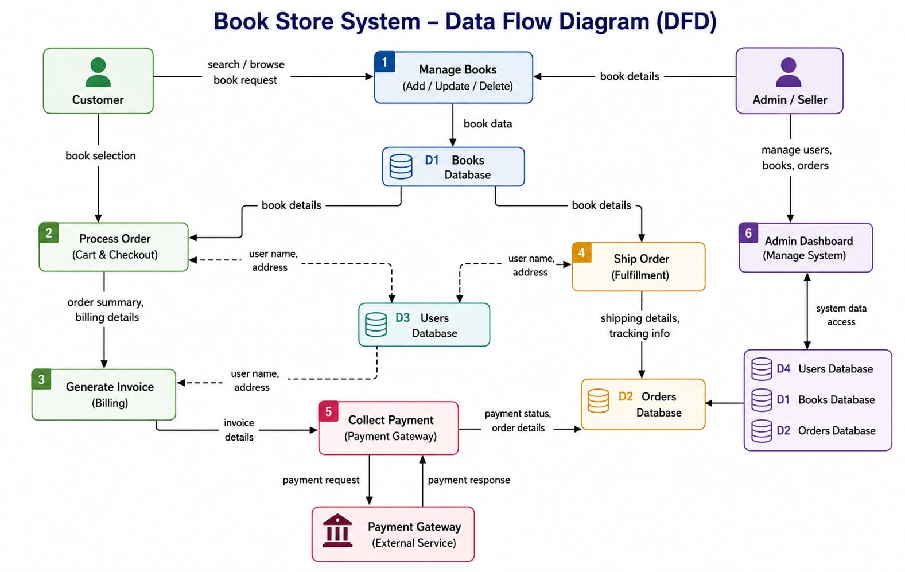

User Stories
Use the below template to list all the user stories for the product.
User Type | Functional Requirement (Epic) | User Story Number | User Story / Task | Acceptance criteria | Priority | Release
Customer (Web User) | Registration | USN-1 | As a user, I can register for the application by entering my email, password, and confirming my password. | User account is created successfully. | High | Sprint-1
Customer (Web User) | Login | USN-2 | As a user, I can log in using my email and password | User is redirected to the home page after successful login. | High | Sprint-1
Customer (Web User) | Book Search | USN-3 | As a user, I can search books by title, author, or category. | Relevant books are displayed based on the search. | High | Sprint-2
Customer (Web User) | Shopping Cart | USN-4 | As a user, I can add or remove books from my shopping cart. | Selected books are updated correctly in the cart. | High | Sprint-3
Customer (Web User) | Order Management | USN-5 | As a user, I can place an order and view my order history. | Order is placed successfully and appears in order history. | High | Sprint-4
Seller | Book Management | USN-6 | As a seller, I can add, edit, and delete books. | Book details are updated successfully in the catalog. | High | Sprint-4
Administrator | Admin Dashboard | USN-7 | As an administrator, I can manage users, books, sellers, and orders. | Admin can perform all management operations successfully. | High | Sprint-4
Customer Care Executive
Administrator

